Why we need Postfix notation

Infix :

a + b * c

Postfix :

a + ( b*c )

a+ (bc*)

abc*+

Prefix :

a + ( b * c )

a + ( * b c )

+a * b c

IMP Note :

In above all 3 Notation , Operand Order doesn’t change, only Operator Order changes.

When Left to Right Scan

Infix

Disadvantage:

Searching Priority Operator to find is too long.

Postfix

Advantage :

No time requires to searching priority Operator.

Note: Postfix notation, No need to worry about operator hierarchy, because higher priority operators are coming first.

Conclusion:

Infix : 2 + 3 * 4

Process will scan full string from left to right in order to determine higher priority. Hence many scan are required to Evaluate the Final answer.

Postfix : 2 3 * +

No need to scan full string, first perfom the operation as soon as you get the operator.

Prefix : + 2 * 3 4

This also requires full scan if scanning is done from left to right.

Conclusion :

Use types in infix form but the computes the Postfix notation before handling code to processor.

Compiler read expression in infix notation(General way) it will convert the infix notation to postfix using oprator stack and then cpu will read the expression in the form of postfix.

Infix to Postfix Conversion

Infix : a + b * c

Postfix : a b c * +

In this we use Only Operator Stack

Note :

Read Expression from Left to right and Take Operator and Put into the Stack and follow the Rules.

Rules

Lower Higher PUSH

Higher Lower POP // EQUAL

Example: a + b * c

Printf a b c * +
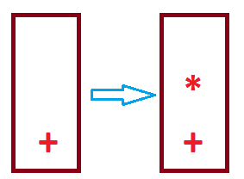

At the End , POP all the elements from the last Updated Stack.

Max Stack Size

Infix to Post fix Conversion Example .

Ques : Infix a + b * c ^ d – e

Priority ^ > * > + > -

Sol :

Print : a b c d ^ * + e –

